MET CS 555 Assignment 1 – 20 points
SUBMISSION REQUIREMENTS: Please submit a single document (word or PDF) for submission. Your submission should contain a summary of your results (and answers to questions asked on the homework) as well as your R code used to generate your results (please append your R code to the end of your submission).
Homework submission filenames should take on the form LASTNAME - Homework #.doc(x)/.pdf.
No ZIP files please.
The data in the table below give the duration in days of hospital stays of patients admitted to the hospital with C. Difficile. Use the data on the following page to:
Note that the data is one column, but the long column has been broken by 10 rows each and they attached to each other in a form table below.
(1) Save the data to a CSV file and read into R for analysis. (2 points)
(2) Make a histogram of the duration of days of hospital stays. Ensure the histogram is labelled appropriately. Use a width of 1 day. Describe the shape, center, and spread of the data. Are there any outliers? (5 points)
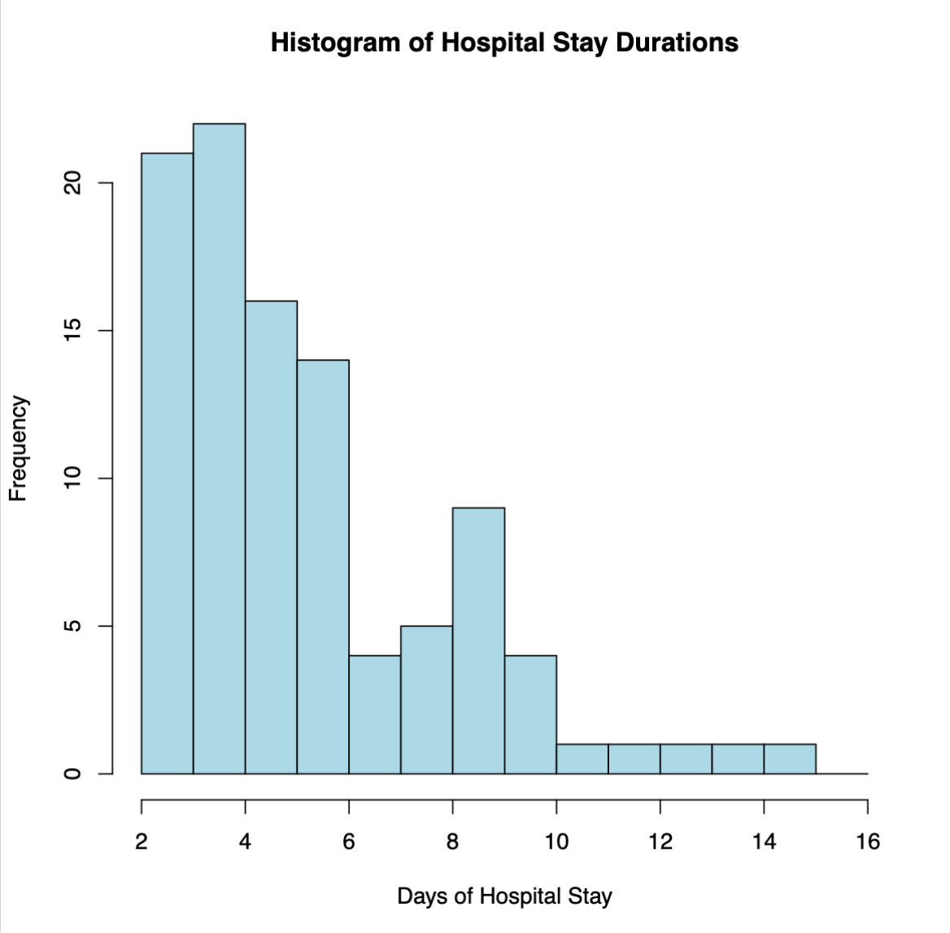

The histogram is right-skewed, the center is around 5, and the spread is from 2 - 15.
Outliers: 15 13 14 12

(3) Find the mean, median, standard deviation, first and third quartiles, minimum and maximum of the durations of hospital stay in the sample. Summarize these values in a table that you create in EXCEL or WORD. In other words, do *not* simply copy and paste R output. You should be reporting a nicely labeled and formatted table.

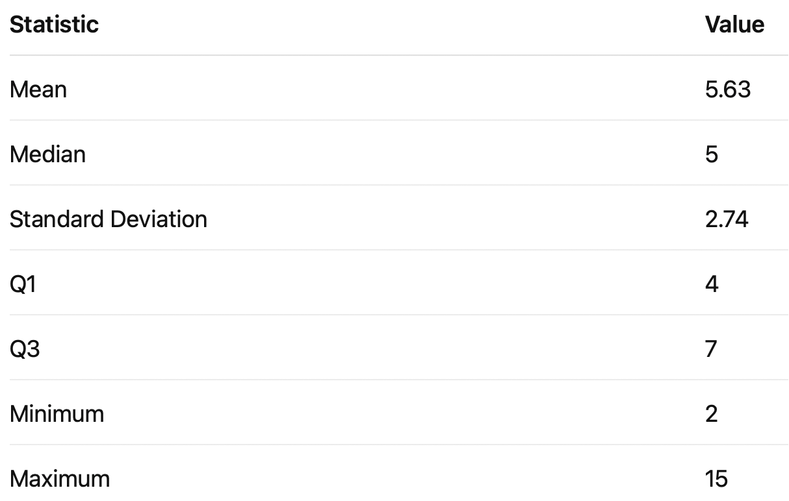

- Given the shape of the distribution, what is the best single number summary of the center of the distribution?
5, because the outliers inflate the mean so we use the median.
- What is the best single number summary of the spread of the distribution? (5 points)
3, we use the interquartile value because of the outliers.
(4) Assume that the literature on this topic suggests that the distribution of days of hospital stay are normally distributed with a mean of 5 and a standard deviation of 3. Use R to determine the probabilities below based on the normal distribution described above (you should not be using the data set given on the following page):
(a) What percentage of patients are in the hospital for less than 10 days? (2 points)
95.22 %
What percentage of patients are in the hospital between 3 and 10 days? (2 points)
69.97 %
(b) Recent publications have indicated that hypervirulent strains of C. Difficile are on the rise. Such strains are associated with poor outcomes, including extended hospital stays. An investigator is interested in showing that the average hospital stay duration have increased versus published literature. He has a sample of 35 patients from his hospital. If the published data are consistent with the truth, what is the probability that the sample mean in his sample will be greater than 6 days? (4 points)
2.4%

Data Set for Assignment 1

7 | 3 | 5 | 3 | 9 | 5 | 10 | 3 | 4 | 4
7 | 5 | 8 | 3 | 4 | 9 | 15 | 4 | 5 | 8
5 | 3 | 2 | 3 | 5 | 9 | 4 | 5 | 6 | 9
5 | 3 | 6 | 3 | 2 | 6 | 4 | 5 | 5 | 4
5 | 8 | 4 | 6 | 13 | 4 | 6 | 3 | 2 | 3
2 | 4 | 6 | 6 | 6 | 8 | 6 | 3 | 4 | 4
5 | 10 | 4 | 6 | 3 | 9 | 3 | 9 | 4 | 7
10 | 14 | 4 | 6 | 5 | 10 | 4 | 4 | 9 | 4
4 | 3 | 6 | 8 | 5 | 7 | 6 | 9 | 3 | 12
11 | 5 | 2 | 9 | 4 | 4 | 5 | 6 | 4 | 2

# Read CSV file into a data frame
data = read.csv("data.csv", header = FALSE)
first_col = data[[1]]
head(first_col)

# Make a histogram of hospital stay durations
hist(first_col,
breaks = seq(min(first_col),
max(first_col) + 1,
by = 1),
main = "Histogram of Hospital Stay Durations",
xlab = "Days of Hospital Stay",
ylab = "Frequency",
col = "lightblue",
border = "black")

# Compute quartiles and IQR
Q1 <- quantile(first_col, 0.25, na.rm = TRUE)
Q3 <- quantile(first_col, 0.75, na.rm = TRUE)
IQR_value <- IQR(first_col, na.rm = TRUE)

# Define outlier bounds
lower_bound <- Q1 - 1.5 * IQR_value
upper_bound <- Q3 + 1.5 * IQR_value

# Identify outliers
outliers <- first_col[first_col < lower_bound | first_col > upper_bound]

# Print results
cat("Q1:", Q1, "\n")
cat("Q3:", Q3, "\n")
cat("IQR:", IQR_value, "\n")
cat("Lower bound:", lower_bound, "\n")
cat("Upper bound:", upper_bound, "\n")
cat("Outliers detected:", outliers, "\n")

# Summary statistics
mean_val <- mean(first_col, na.rm = TRUE)
median_val <- median(first_col, na.rm = TRUE)
sd_val <- sd(first_col, na.rm = TRUE)
min_val <- min(first_col, na.rm = TRUE)
max_val <- max(first_col, na.rm = TRUE)

cat("\nSummary Statistics:\n")
cat("Mean:", mean_val, "\n")
cat("Median:", median_val, "\n")
cat("Standard Deviation:", sd_val, "\n")
cat("Q1:", Q1, "\n")
cat("Q3:", Q3, "\n")
cat("Minimum:", min_val, "\n")
cat("Maximum:", max_val, "\n")

# Create summary table
summary_table <- data.frame(
Statistic = c("Mean", "Median", "Standard Deviation", "Q1", "Q3", "Minimum", "Maximum"),
Value = c(mean_val, median_val, sd_val, Q1, Q3, min_val, max_val)
)

print(summary_table, row.names = FALSE)

# Probabilities based on normal distribution N(5, 3^2)
mean_norm <- 5
sd_norm <- 3

# (a) P(X < 10)
p_less_10 <- pnorm(10, mean = mean_norm, sd = sd_norm)

# (b) P(3 <= X <= 10)
p_between_3_10 <- pnorm(10, mean = mean_norm, sd = sd_norm) - pnorm(3, mean = mean_norm, sd = sd_norm)

cat("\nProbabilities (Normal distribution N(5,3^2)):\n")
cat("Percentage of patients with stays < 10 days:", round(p_less_10 * 100, 2), "%\n")
cat("Percentage of patients with stays between 3 and 10 days:", round(p_between_3_10 * 100, 2), "%\n")

# last question

mu = 5
sigma = 3
n = 35

sigma_clt = 3 / sqrt(35)
z_score = (6 - mu) / sigma_clt

p = pnorm(z_score,lower.tail = FALSE)
cat("The probability of observing a sample with mean > 6 is ", p)

